**Applications Development Project 3**

**Software Requirements Specification (SRS)**

I have read, understood and agree to the contents of this document. I accept full responsibility for any errors and omissions in this document.

Group number: 33 Group name: Super Strikaz



|  |  |
| --- | --- |
| Business Domain | Photography |
| Business name | Foto45 |
| Contact Person | Njabulo Hadebe |
| Contact number | 031 304 8905 |
| Email address | jaybhungane@gmail.com |

Contents

1. Executive summary 3

2. Business use cases 3

3. Detailed use case description 4

4. User Manual 8

5. Minutes 17

# Executive summary

The purpose of this research project is to establish an online platform for artists, “people who specialise in Photography and/or Videography” to sell their services and skills to potential clients and event planners.

This application is supposed to make life easier for models, event planners, and your average individual, who requires professional Photography and/or Videography from our artists. The photographers will benefit as well, since they will have the opportunity for more jobs, which means more money.

The name of the company is Foto45 it is allocated at the Shop 10/11, 359 Murchies Passage, Durban Central. They want to expand and cater more services to their clients. Their clients enjoy their services and demand more of their services and a way to have easy access to those services.

# Business use cases

|  |  |  |  |  |
| --- | --- | --- | --- | --- |
| **No** | **Use case** | **Brief Use Case description** | **Full Name** | **Completed Yes / No** |
| **First Semester Use cases** | | | | |
| 1 | Add to cart (Purchase an item) | A customer selects all the products they want to buy, update the quantity of products and checkout to shipping and make a payment | Jabulani Cele/  Asiphe Ndamase | Yes |
| 2 | Checkout (Create order) | A customer has selected all the products and updated the quantity of products they want to buy, now they want checkout to shipping and complete their order making process. | Lucky Hlongwane/ Themba Ntshangase | Yes |
| 3 | Send order notification (Complete order) | A customer wishes to get a notification, after they have completed the process of creating an order. | Bongani Hlophe/  Shaylin Naidoo | Yes |
| **Second Semester Use cases** | | | | |
|  | Book an Artist | If a customer already has a profile, they can make a booking by entering date, time, and location of the event. They will have to provide all required details that are required for the event they will be hosting and service they require | Jabulani Cele/  Lucky Hlongwane/ Themba Ntshangase | *Yes* |
|  | Booking Cancellation by Artist | Admin wants to assign an artist to a booking that was cancelled by an artist. | Jabulani Cele  Lucky Hlongwane | No |
|  | Booking Cancellation by Customer | Customer wants to cancel their booking the system will check the date if the cancellation date has not passed, then system will notify Artist and Admin about the cancellation | Lucky Hlongwane/  Jabulani Cele | No |
|  | Client Cancel Order | A Client selects an order they want to cancel, select cancel and the order status is updated to cancel. | Asiphe Ndamase /Themba Ntshangase | *Yes* |
|  | Admin Deletes A Cancelled order | If a client has cancelled an order that order needs to be deleted from the current orders that have continuous processes. | Asiphe Ndamase/  Bongane Hlophe | *Yes* |
|  | Create/Remove Product Special | The Admin can make a Special on certain products by selecting and adding a Special for each product. Also, An Admin can cancel a Special on a product. | Asiphe Ndamase/  Shaylin  Naidoo | *Yes* |
|  | Manage Inventory | Tracking the amount of stock available in inventory and ordering new items if stock is less than the specified limit | Asiphe Ndamase | *Yes* |

# Detailed use case description

**First semester Use cases**

|  |  |  |
| --- | --- | --- |
| **Use case number** | 1 | |
| **Use case name** | Add to cart (Purchase an item) | |
| **Triggering event** | A customer wants to purchase items | |
| **Brief description** | A customer selects all the products they want to buy, update the quantity of products and checkout to shipping and make a payment | |
| **Actors** | Customer | |
| **Preconditions** | Items for purchase must be available | |
| **Flow of activities** | Customer   * View products catalog * Select product * Add product to cart * modify cart details as required * Review cart detail * Proceed to checkout | System   * Gets the selected products * Create cart * Update cart * Calculate total cost * Checks if user is logged in * If user is not logged in redirect them to log in |

|  |  |  |
| --- | --- | --- |
| **Use case number** | 2 | |
| **Use case name** | Checkout (Create order) | |
| **Triggering event** | A customer wants to create an order | |
| **Brief description** | A customer has selected all the products and updated the quantity of products they want to buy, now they want checkout to shipping and complete their order making process. | |
| **Actors** | Customer | |
| **Preconditions** | Items for purchase must be available cart | |
| **Flow of activities** | Customer   * View Order list * Modify order details as required * Review and confirm order details * Add delivery information and address * Procced to Process order | System   * Gets the product list/ order detail * If order is changed redirect user to cart * Calculates cost * Confirm customer and delivery information |

|  |  |  |
| --- | --- | --- |
| **Use case number** | 3 | |
| **Use case name** | Send order notification (Complete order) | |
| **Triggering event** | A customer completes an order | |
| **Brief description** | A customer wishes to get a notification, after they have completed the process of creating an order. | |
| **Actors** | Customer | |
| **Preconditions** | Items for purchase must be available  A valid billing account must be provided | |
| **Flow of activities** | Customer   * Add delivery information Name, phone, and address details * Add an email address * Completes order prosses | System   * Gets customer information * Confirms order detail * Calculates cost * Confirm customer and delivery information * Send email notification |

**Second semester Use cases**

|  |  |
| --- | --- |
| **Use case number** | 1 |
| **Use case name** | Book an Artist |
| **Triggering event** | A customer wants to book an artist for an event they will be hosting. |
| **Brief description** | If a customer already has a profile, they can make a booking by entering event, date, time, and location of the event. They will have to provide all required details that are required for the event they will be hosting and service they require. |
| **Actors** | Customer |
| **Preconditions** | Account registration must be valid Client profile must be available Artist must be available. |
| **Flow of activities** | 1. Enter details of the event 2. Select/ enter date of event 3. View available artists 4. Select artist 5. System gets customers event and artist booking information 6. System assigns artist if no artist selected 7. Confirm booking details 8. Proceed to payment 9. Send notification of booking to customer |

|  |  |
| --- | --- |
| **Use case number** | 2 |
| **Use case name** | Booking Cancellation by Artist |
| **Triggering event** | The Artist Cancels a booking. |
| **Brief description** | Admin wants to assign an artist to a booking that was cancelled by an artist. |
| **Actors** | Admin  Artist |
| **Preconditions** | Bookings must be available on the Artist schedule. |
| **Flow of activities** | 1. Artist Reviews their Bookings 2. Artist Cancels their booking Assignment 3. System Sends Notification of cancellation to Admin 4. The admin reviews cancelled bookings 5. The admin assigns an artist for the booked event 6. System Sends Notification to the Assigned Artist 7. System Sends Notification to the Customer |

|  |  |
| --- | --- |
| **Use case number** | 3 |
| **Use case name** | Booking Cancellation by Customer |
| **Triggering event** | Customer Cancels their Booking |
| **Brief description** | Customer wants to cancel their booking the system will check the date if the cancellation date has not passed, then system will notify Artist and Admin about the cancellation. |
| **Actors** | Customer  Artist  Admin |
| **Preconditions** | Bookings must be available on the Customer schedule |
| **Flow of activities** | 1. Customer reviews their Bookings 2. Customer cancels their booking 3. System Sends Notification of cancellation to Admin and to the Assigned Artist 4. System Updates Customer bookings |

|  |  |
| --- | --- |
| **Use case number** | 4 |
| **Use case name** | Client Cancel Order |
| **Triggering event** | The Client wants to cancel one of their orders. |
| **Brief description** | A Client selects an order they want to cancel, select cancel and the order status is updated to cancel. |
| **Actors** | Client |
| **Preconditions** | Client must login, An Order must be available in the Client Order list. |
| **Flow of activities** | 1. Client View All orders 2. System retrieves all customer orders. 3. Client Select An order to cancel. 4. Client Cancel order 5. System sends an email notification about the order cancellation |

|  |  |
| --- | --- |
| **Use case number** | 5 |
| **Use case name** | Admin Deletes a Cancelled order |
| **Triggering event** | Order review |
| **Brief description** | If a client has cancelled an order that order needs to be deleted from the current orders that have continuous processes. |
| **Actors** | Client, Admin |
| **Preconditions** | Client Cancelled an Order. |
| **Flow of activities** | 1. Admin views all orders 2. System Retrieves/filters all cancelled orders 3. Admin Selects and Deletes Cancelled orders 4. System updates orders list. |

|  |  |
| --- | --- |
| **Use case number** | 6 |
| **Use case name** | Create/Remove Product Special |
| **Triggering event** | An Admin wants to create a Special on selected products |
| **Brief description** | The Admin can make a Special on certain products by selecting and adding a Special for each product. Also, An Admin can cancel a Special on a product. |
| **Actors** | Admin |
| **Preconditions** | Products must be available in the store inventory. |
| **Flow of activities** | 1. Check stock availability 2. Select product preferred 3. Add Special to product/ Cancel product Special |

|  |  |
| --- | --- |
| **Use case number** | 7 |
| **Use case name** | Manage Inventory |
| **Triggering event** | Add a products to Inventory |
| **Brief description** | Tracking the amount of stock available in inventory and ordering new items if stock is less than the specified limit. |
| **Actors** | Admin |
| **Preconditions** | Stock availability is low or below a certain amount. |
| **Flow of activities** | 1. Check stock availably 2. Notify admin of low stock 3. Update stock items |

# User Manual

* 1. Access detail – you are required to setup the URL using the year and Group eg.

Deployment: https: azurewebsites.net

* 1. Login details

{

Admin: [SuperAdmin@gmail.com](mailto:SuperAdmin@gmail.com), Password: Password@2020

Client: Register Account.

}

* 1. Usage of the business use cases only

Home Page

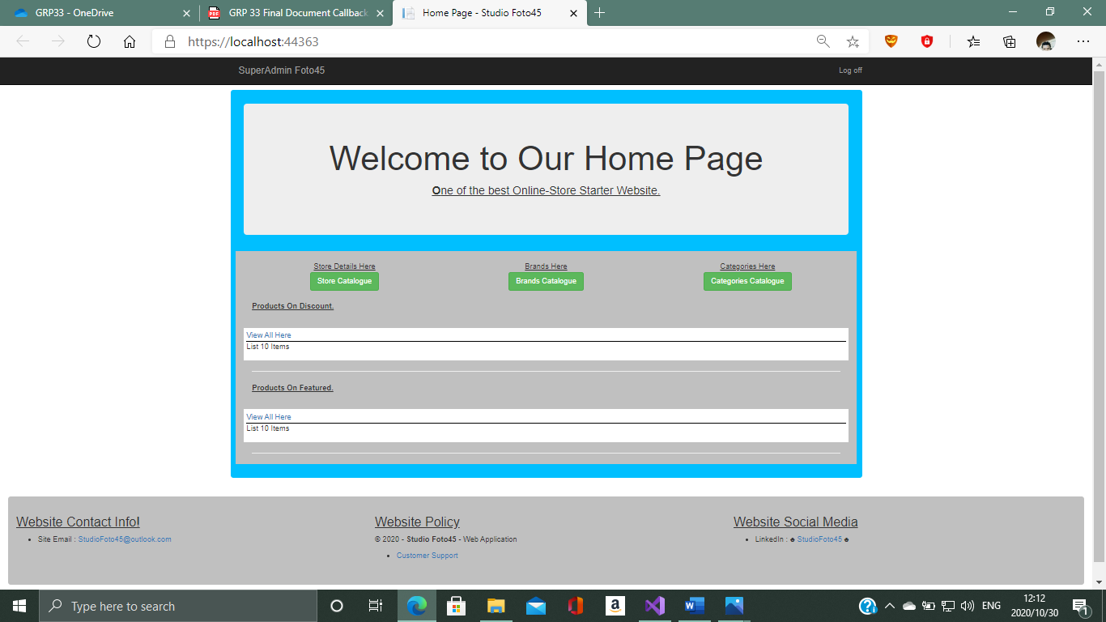

This Is the Home Page Of Our Application

1. Catalogue
2. Brands
3. Categories

Product Catalogue

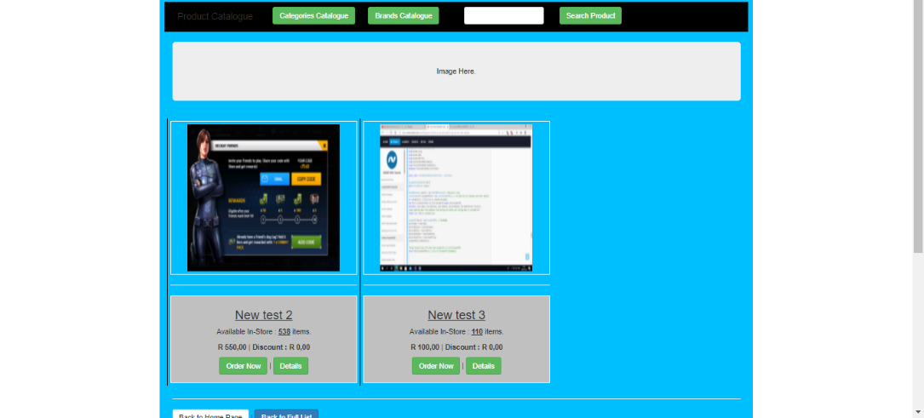

Product Catalogue Page

All Products Added to be visible Are shown here for display.

You can search, add to cart or you can see product details.

Shopping Cart

Update Quantity / Remove Item from Shopping Cart

Shopping Cart Page

All added products if any,

A client can update their product purchase quantity.

They can delete a product from the shopping cart.

Also Update their cart.

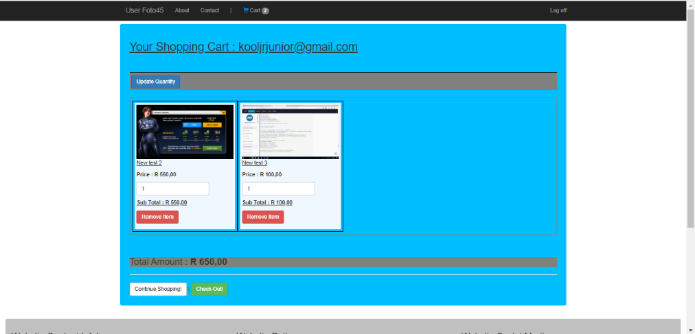

Check-Out Order

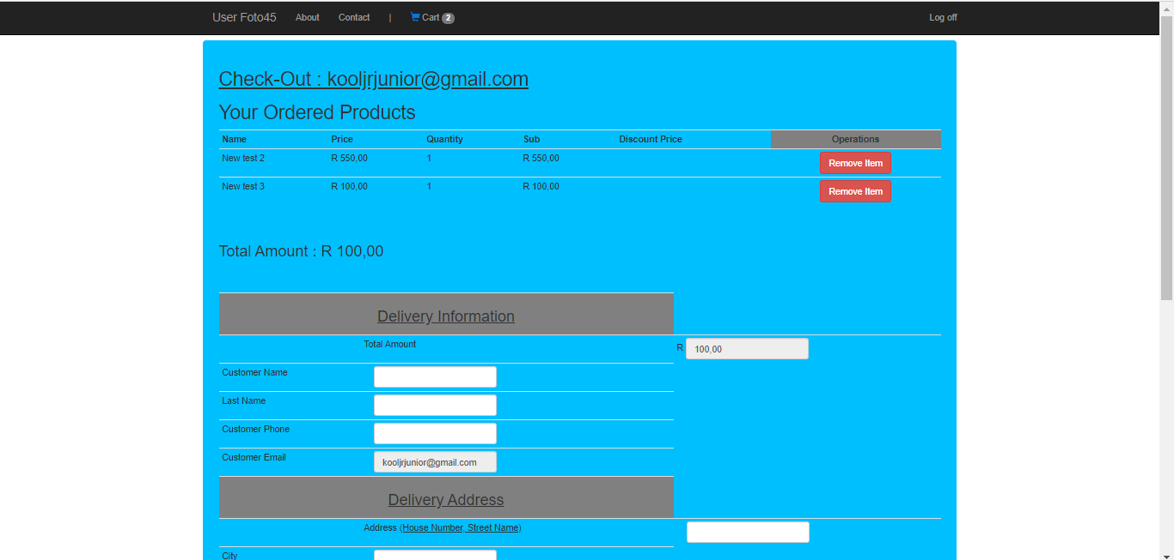

Check-Out Page

Client See all the products in their shopping cart.

Final total is calculated

And this where a client creates an order

Process Order (Create Order)

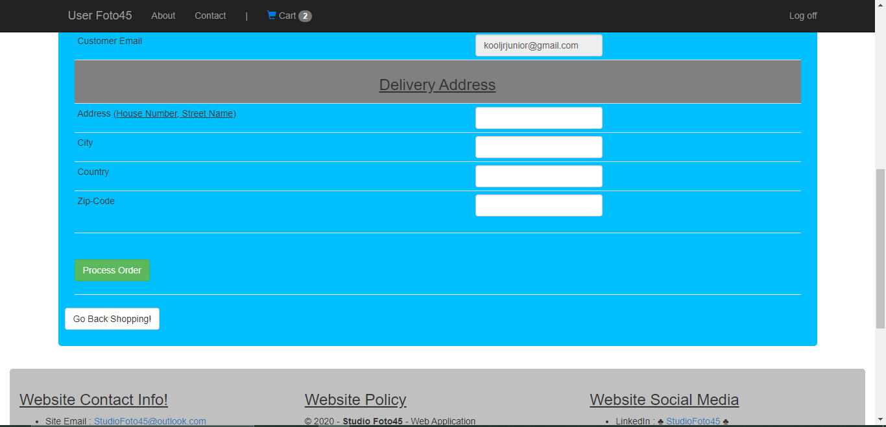

After the order has been processed a notification is sent to the client,

while their order list is being updated by the system.

Client Dashboard

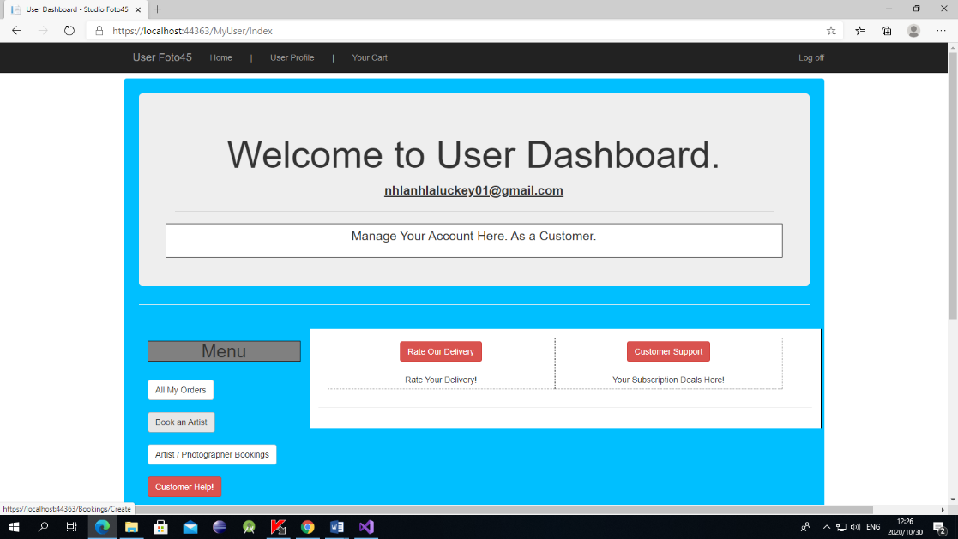

User Client Dashboard

Links to all the desired pages:

Orders List

Book an Artist and All their Bookings

Order Success Page

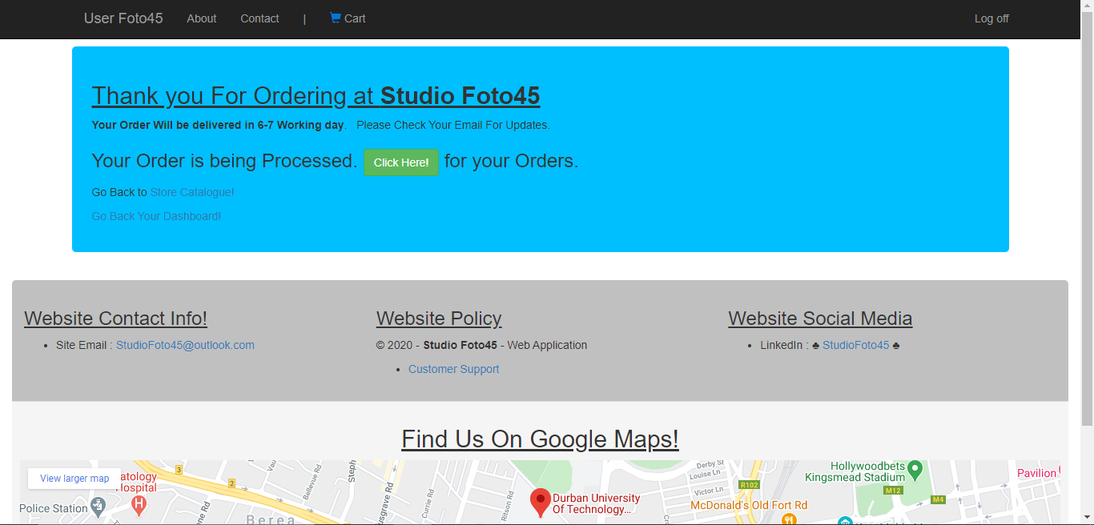

After Checking out

A success page is displayed to confirm that the order has been created and that a notification has been sent to the clients email.

Order Email Notification

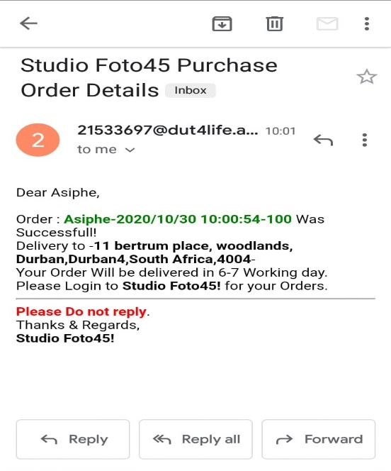

This is the order notification that is sent to the client when create an order.

It has the name of the store, some user details and the delivery address.

Customer Order List (Processing & Approved)

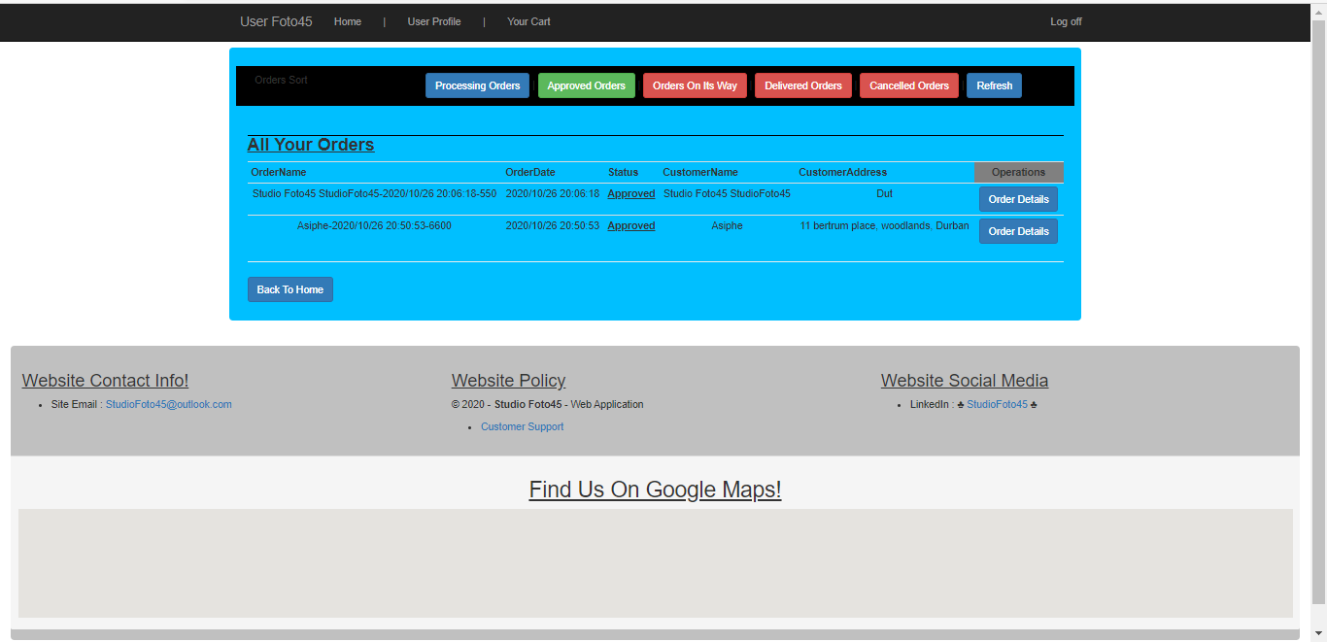

Order list Page

All orders ordered by that client are displayed in their orders list. They can search for an order name based on the order they provide for delivery

Customer Order Details & Status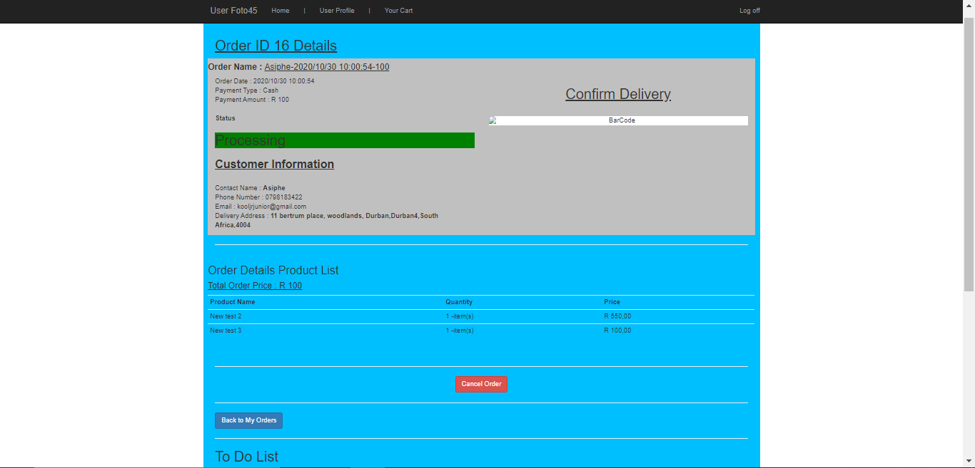

List of all the items in an order.

Details about the client ordering or the client being delivered to.

Client has the option to cancel their booking.

Book an Artist

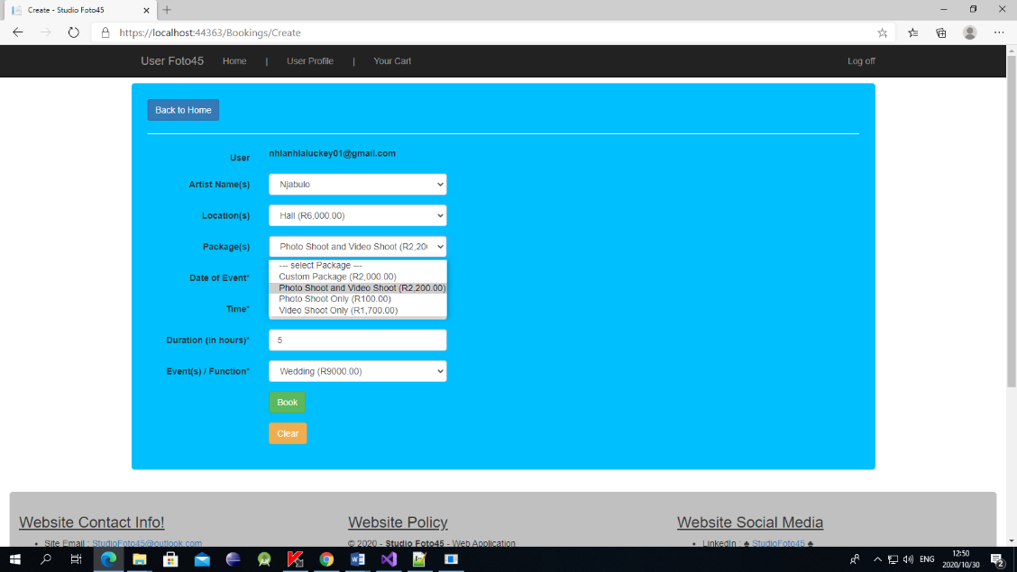

This is the artis booking page,

Book an artist and select specific items or packages for your event.

Client Bookings

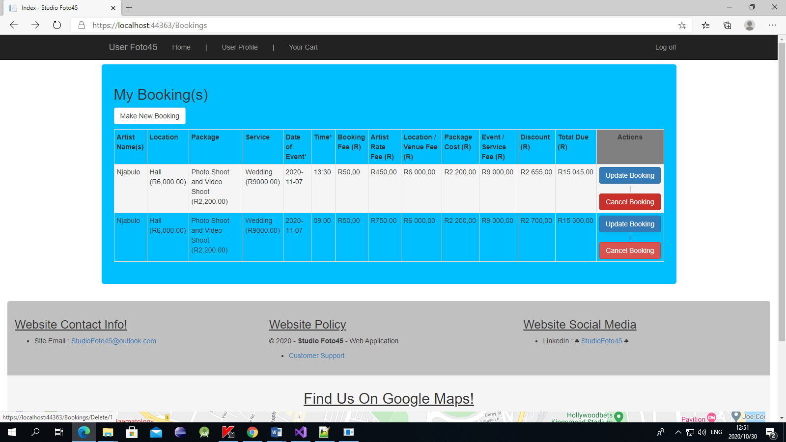

All Clients bookings are displayed on this page.

You can update booking, or you can cancel or delete Booking

**ADMINISTRATOR PAGE**

Admin Dashboard

Administration page

Inventory,

Orders,

Products,

Category list,

App Users

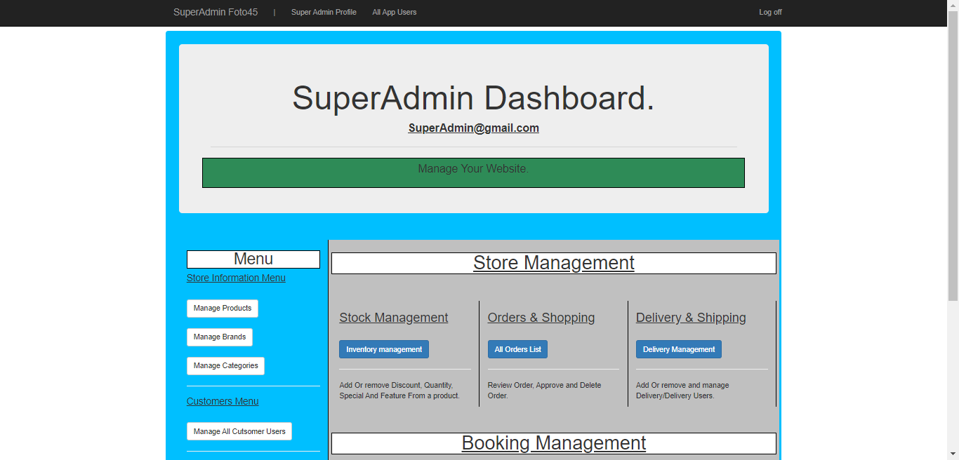

App Users

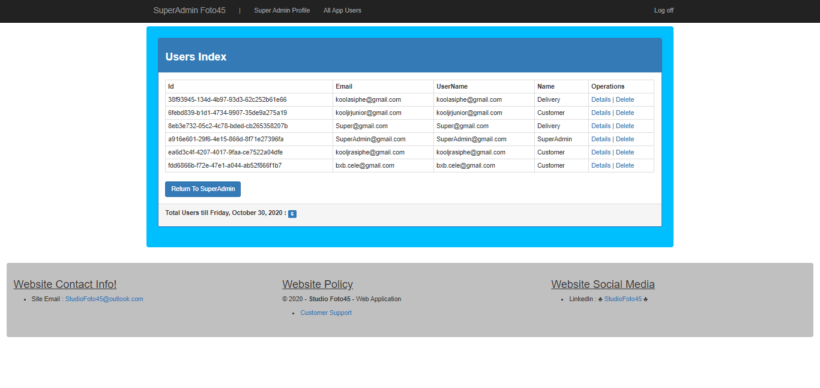

All App Users And all their roles

Admin can delete or add a role and an Artist, delivery personnel

Add Product

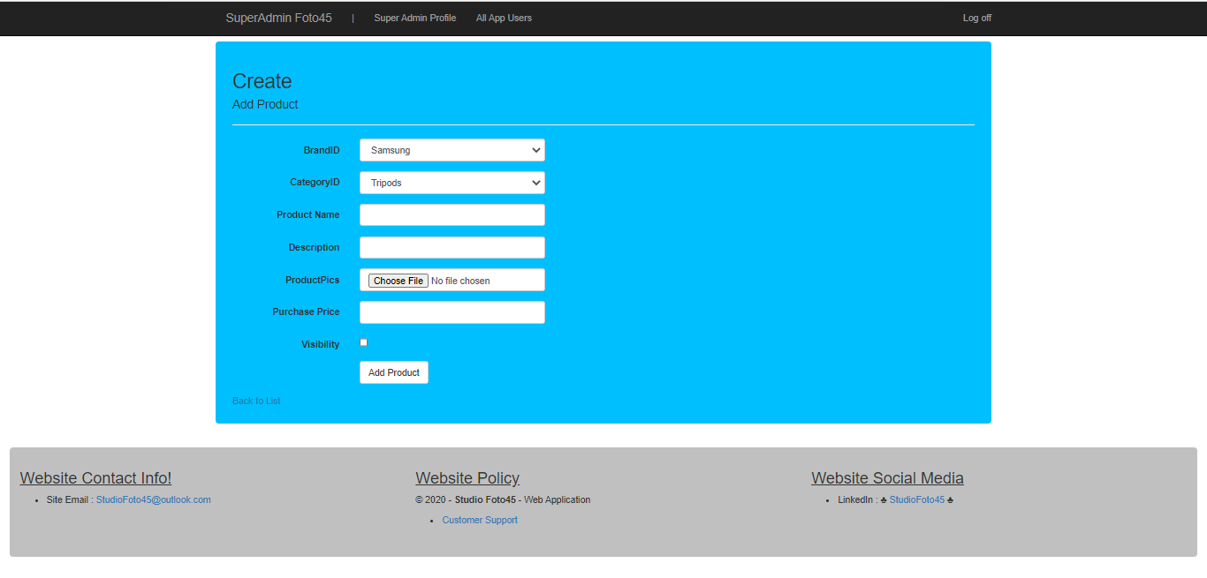

Administrator can add a product

To the inventory

Based on its brand and category

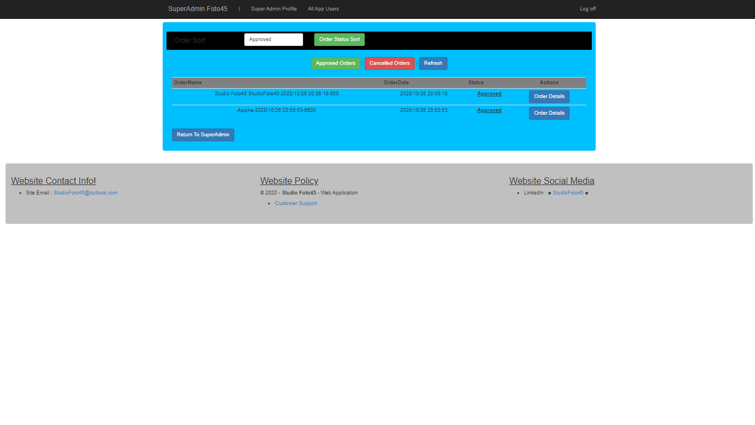All Orders List (Approve & Delete Order)

A List of all the orders that have been made, orders waiting to be approved and all the client cancelled

Order Details (Approve & Delete)

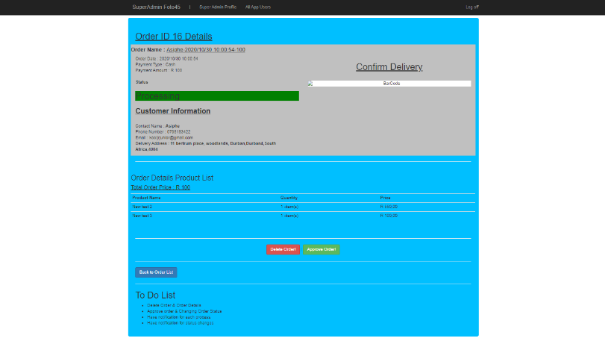

An Order detail for an admin Encompasses,

1.Delete Order

2.Approve order

Depending on the update status from the client.

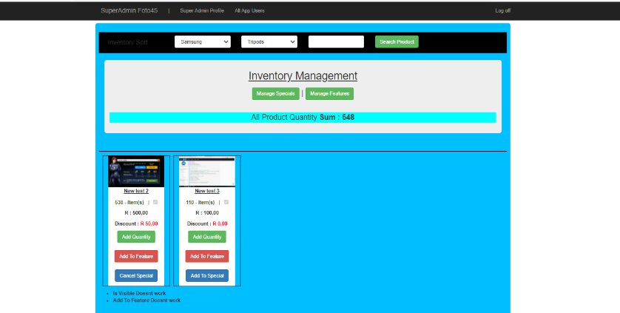Inventory Management

Inventory Management

1. Ad Quantity
2. Add to Special
3. And Add to Featured products

All Managements are sort list

Add Quantity

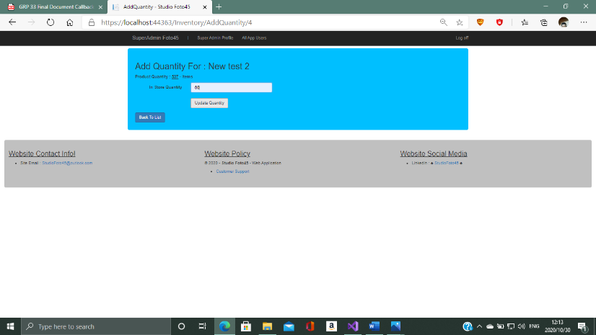

Add quantity to a product if its background is red, it shows that its less than hundred items left.

This only updates it doesn’t minus items.

Add to Special

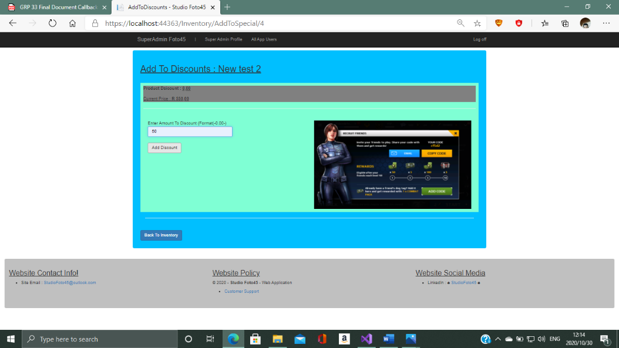

A product can be added to the special tab when an admin creates a discount for that product.

Also, the admin can cancel that discount if they want it be.

# Minutes

|  |  |  |  |
| --- | --- | --- | --- |
| **Date /Time (start and end):** Date:10/09/2020 (20:00/ 21:15) | | | |
| **Item No** | **(Work - allocated / completed / Outstanding, Decisions Taken)** | **Person responsible** | **Due Date** |
|  | First meeting After presentation | group |  |
|  | **Allocated work** |  |  |
|  | Detailed use case description - Make a booking | Jabulani Cele  Themba Ntshangase | 16/09/2020 |
|  | Detailed use case description - Cancel Booking | Lucky Hlongwane | 16/09/2020 |
|  | Detailed use case description – Rate or Evaluate service | Jabulani Cele | 16/09/2020 |
|  | **Completed work** |  |  |
|  | Add to cart (Purchase an item) | Jabulani Cele  Asiphe |  |
|  | Checkout (Create order) | Lucky Hlongwane Themba Ntshangase |  |
|  | Send order notification (Complete order) | Shaylin Bongane B |  |
|  | **Outstanding work** |  |  |
|  |  |  |  |
|  | **Decisions Taken** |  |  |
|  | Zolile Ntshangase: Notice: every group member needs to research about their use case.  Zolile Ntshangase: research on the, -functionality, -page navigations, -the number of user interfaces that use case needs( for example if you are booking you need these interfaces, create booking, confirm booking, add payment details), and you also need to know/ research on the structure the code of your use case. |  |  |

|  |  |  |  |
| --- | --- | --- | --- |
| **Date /Time (start and end):** Date:16/09/2020 (20:00/ 22:00) | | | |
| **Item No** | **(Work - allocated / completed / Outstanding, Decisions Taken)** | **Person responsible** | **Due Date** |
|  | **Allocated work** |  |  |
|  | Finalization of use case Description and initial coding of - Make a booking | Jabulani Cele Themba Ntshangase | 28/09/2020 |
|  | Finalization of use case Description and initial coding of - Cancel Booking | Lucky Hlongwane | 28/09/2020 |
|  | Finalization of use case Description and initial coding of - Rate or Evaluate service | Jabulani Cele  Shaylin | 28/09/2020 |
|  | Detailed use case description, Finalization of use case Description and initial coding of - Confirm/ Change delivery status | Asiphe | 28/09/2020 |
|  | Detailed use case description, Finalization of use case Description and initial coding of - Get a Discount | Bongane B | 28/09/2020 |
|  | Detailed use case description, Finalization of use case Description and initial coding of - Manage Stock and Inventory | Asiphe | 28/09/2020 |
|  | **Completed work** |  |  |
|  | Detailed use case description - Make a booking | Jabulani Cele  Themba Ntshangase | 14/09/2020 |
|  | Detailed use case description - Cancel Booking | Lucky Hlongwane | 14/07/2020 |
|  | Detailed use case description – Rate or Evaluate service | Jabulani Cele  Shaylin | 14/09/2020 |
|  |  |  |  |
|  | **Outstanding work** |  |  |
|  |  |  |  |
|  | **Decisions Taken** |  |  |
|  |  |  |  |

|  |  |  |  |
| --- | --- | --- | --- |
| **Date /Time (start and end):** Date:28/09/2020 (20:00/ 21:15) | | | |
| **Item No** | **(Work - allocated / completed / Outstanding, Decisions Taken)** | **Person responsible** | **Due Date** |
|  | **Allocated work** |  |  |
|  | First prototyping - Make a booking | Jabulani Cele  Themba Ntshangase | 06/10/2020 |
|  | First prototyping - Cancel Booking | Lucky Hlongwane | 06/10/2020 |
|  | First prototyping - Rate or Evaluate service | Jabulani Cele  Shaylin | 06/10/2020 |
|  | First prototyping - Confirm/ Change delivery status | Asiphe | 06/10/2020 |
|  | First prototyping - Get a Discount | Bongane B | 06/10/2020 |
|  | First prototyping - Manage Stock and Inventory | Asiphe | 06/10/2020 |
|  |  |  |  |
|  | **Completed work** |  |  |
|  | Finalization of use case Description and initial coding of - Make a booking | Jabulani Cele  Themba Ntshangase | 28/09/2020 |
|  | Finalization of use case Description - Cancel Booking | Lucky Hlongwane | 28/09/2020 |
|  | Finalization of use case Description and initial coding of - Rate or Evaluate service | Jabulani Cele  Shaylin | 28/09/2020 |
|  | Detailed use case description, Finalization of use case Description of - Confirm/ Change delivery status | Asiphe | 28/09/2020 |
|  | Detailed use case description, Finalization of use case Description and initial coding of - Get a Discount | Bongane B | 28/09/2020 |
|  | Detailed use case description, Finalization of use case Description and initial coding of - Manage Stock and Inventory | Asiphe | 28/09/2020 |
|  |  |  |  |
|  | **Outstanding work** |  |  |
|  | Initial coding for cancel Booking | Lucky Hlongwane | 28/09/2020 |
|  | Initial coding for Get a discount | Bongane B | 28/09/2020 |
|  |  |  |  |
|  | **Decisions Taken** |  |  |
|  | Request print use case will be done in the second increment |  |  |

|  |  |  |  |
| --- | --- | --- | --- |
| **Date /Time (start and end):** Date:30/09/2020 (20:00/ 21:15) | | | |
| **Item No** | **(Work - allocated / completed / Outstanding, Decisions Taken)** | **Person responsible** | **Due Date** |
|  | **Allocated work** |  |  |
|  | First prototyping - Make a booking | Jabulani Cele  Themba Ntshangase | 06/10/2020 |
|  | First prototyping - Cancel Booking | Lucky Hlongwane | 06/10/2020 |
|  | First prototyping - Rate or Evaluate service | Jabulani Cele  Shaylin N | 06/10/2020 |
|  | First prototyping - Confirm/ Change delivery status | Asiphe | 06/10/2020 |
|  | First prototyping - Get a Discount | Bongane B | 06/10/2020 |
|  | First prototyping - Manage Stock and Inventory | Asiphe N | 06/10/2020 |
|  |  |  |  |
|  | **Completed work** |  |  |
|  |  |  |  |
|  |  |  |  |
|  | **Outstanding work** |  |  |
|  | First prototyping - Make a booking | Jabulani Cele  Themba Ntshangase | 06/10/2020 |
|  | First prototyping - Cancel Booking | Lucky Hlongwane | 06/10/2020 |
|  | First prototyping - Rate or Evaluate service | Jabulani Cele  Shaylin | 06/10/2020 |
|  | First prototyping - Confirm/ Change delivery status | Asiphe | 06/10/2020 |
|  | First prototyping - Get a Discount | Bongane B | 06/10/2020 |
|  | First prototyping - Manage Stock and Inventory | Asiphe N | 06/10/2020 |
|  |  |  |  |
|  | **Decisions Taken** |  |  |
|  |  |  |  |

|  |  |  |  |
| --- | --- | --- | --- |
| **Date /Time (start and end):** Date:06/10/2020 (20:00/ 21:15) | | | |
| **Item No** | **(Work - allocated / completed / Outstanding, Decisions Taken)** | **Person responsible** | **Due Date** |
|  | **Allocated work** |  |  |
|  | Final coding for - Make a booking | Jabulani Cele  Themba Ntshangase | 09/10/2020 |
|  | Final coding for - Cancel Booking | Lucky Hlongwane | 09/10/2020 |
|  | First coding for - Rate or Evaluate service | Jabulani Cele  Shaylin N | 09/10/2020 |
|  | Final coding for - Client Cancel Order | Asiphe  Ndamase  /Themba Ntshangase | 09/10/2020 |
|  | Final coding for - Create/Remove Product Special | Asiphe Ndamase/  Shaylin  Naidoo | 09/10/2020 |
|  | Final coding for - Admin Deletes A Cancelled order | Asiphe Ndamase/  Bongane Hlophe | 09/10/2020 |
|  | Final coding for - Manage Stock and Inventory | Asiphe Ndamase | 09/10/2020 |
|  |  |  |  |
|  | **Completed work** |  |  |
|  | First prototyping - Make a booking | Jabulani Cele  Themba Ntshangase | 06/10/2020 |
|  | First prototyping - Cancel Booking | Lucky Hlongwane | 06/10/2020 |
|  | First prototyping - Rate or Evaluate service | Jabulani Cele Shaylin | 06/10/2020 |
|  | First prototyping - Confirm/ Change delivery status | Asiphe N | 06/10/2020 |
|  | First prototyping - Get a Discount | Bongane B | 06/10/2020 |
|  | First prototyping - Manage Stock and Inventory | Asiphe | 06/10/2020 |
|  | First prototyping - Make a booking | Jabulani Cele  Themba Ntshangase | 06/10/2020 |
|  |  |  |  |
|  | **Outstanding work** |  |  |
|  |  |  |  |
|  | **Decisions Taken** |  |  |
|  | Get a discount use-case will be changed to Create or remove product special |  |  |

|  |  |  |  |
| --- | --- | --- | --- |
| **Date /Time (start and end):** Date:07/10/2020 (20:00/ 21:15) | | | |
| **Item No** | **(Work - allocated / completed / Outstanding, Decisions Taken)** | **Person responsible** | **Due Date** |
|  | **Allocated work** |  |  |
|  | Final coding for - Make a booking | Jabulani Cele  Themba Ntshangase | 09/10/2020 |
|  | Final coding for - Cancel Booking | Lucky Hlongwane | 09/10/2020 |
|  | First coding for - Rate or Evaluate service | Jabulani Cele  Shaylin | 09/10/2020 |
|  | Final coding for - Client Cancel Order | Asiphe  Ndamase  /Themba Ntshangase | 09/10/2020 |
|  | Final coding for - Create/Remove Product Special | Asiphe Ndamase/  Shaylin  Naidoo | 09/10/2020 |
|  | Final coding for - Admin Deletes A Cancelled order | Asiphe Ndamase/  Bongane Hlophe | 09/10/2020 |
|  | Final coding for - Manage Stock and Inventory | Asiphe | 09/10/2020 |
|  |  |  |  |
|  | **Completed work** |  |  |
|  |  |  |  |
|  | **Outstanding work** |  |  |
|  | Final coding for - Make a booking | Jabulani Cele  Themba Ntshangase | 09/10/2020 |
|  | Final coding for - Cancel Booking | Lucky Hlongwane | 09/10/2020 |
|  | First prototyping - Rate or Evaluate service | Jabulani Cele  Shaylin | 09/10/2020 |
|  | Final coding for - Client Cancel Order | Asiphe  /Themba Ntshangase | 09/10/2020 |
|  | Final coding for - Create/Remove Product Special | Asiphe Ndamase/  Shaylin  Naidoo | 09/10/2020 |
|  | Final coding for - Admin Deletes A Cancelled order | Asiphe Ndamase/  Bongane Hlophe | 09/10/2020 |
|  | Final coding for - Manage Stock and Inventory | Asiphe | 09/10/2020 |
|  |  |  |  |
|  | **Decisions Taken** |  |  |
|  | This meeting was to check progress |  |  |

|  |  |  |  |
| --- | --- | --- | --- |
| **Date /Time (start and end):** Date:09/10/2020 (20:00/ 21:15) | | | |
| **Item No** | **(Work - allocated / completed / Outstanding, Decisions Taken)** | **Person responsible** | **Due Date** |
|  | **Allocated work** |  |  |
|  | Final coding for - Make a booking | Jabulani Cele  Themba Ntshangase | 14/10/2020 |
|  | Final coding for - Cancel Booking | Lucky Hlongwane | 14/10/2020 |
|  | Final coding for - Rate or Evaluate service | Jabulani Cele  Shaylin | 14/10/2020 |
|  |  |  |  |
|  | **Completed work** |  |  |
|  | Final coding for -, Client Cancel Order | Asiphe Ndamase  /Themba Ntshangase | 09/10/2020 |
|  | Final coding for - Create/Remove Product Special | Asiphe Ndamase/  Shaylin  Naidoo | 09/10/2020 |
|  | Final coding for - Admin Deletes A Cancelled order | Asiphe Ndamase/  Bongane Hlophe | 09/10/2020 |
|  | Final coding for - Manage Stock and Inventory | Asiphe Ndamase | 09/10/2020 |
|  |  |  |  |
|  | **Outstanding work** |  |  |
|  | Final coding for - Make a booking | Jabulani Cele  Themba Ntshangase | 09/10/2020 |
|  | Final coding for - Cancel Booking | Lucky Hlongwane | 09/10/2020 |
|  | Final coding for - Rate or Evaluate service | Jabulani Cele  Shaylin | 09/10/2020 |
|  |  |  |  |
|  | **Decisions Taken** |  |  |
|  | All use cases need to be refined and more detailed for SRS document |  |  |

|  |  |  |  |
| --- | --- | --- | --- |
| **Date /Time (start and end):** Date:11/10/2020 (20:00/ 21:15) | | | |
| **Item No** | **(Work - allocated / completed / Outstanding, Decisions Taken)** | **Person responsible** | **Due Date** |
|  | **Allocated work** |  |  |
|  | Coding Corrections for - Make a booking | Jabulani Cele  Themba Ntshangase | 14/10/2020 |
|  | Coding Corrections for - Cancel Booking | Lucky Hlongwane | 14/10/2020 |
|  | Coding Corrections for - Rate or Evaluate service | Jabulani Cele  Shaylin | 14/10/2020 |
|  | Coding Corrections for - Client Cancel Order | Asiphe Ndamase  /Themba Ntshangase | 14/10/2020 |
|  | Coding Corrections for - Create/Remove Product Special | Asiphe Ndamase/  Shaylin  Naidoo | 14/10/2020 |
|  | Coding Corrections for - Admin Deletes A Cancelled order | Asiphe Ndamase/  Bongane Hlophe | 14/10/2020 |
|  | Coding Corrections for - Manage Stock and Inventory | Asiphe Ndamase | 14/10/2020 |
|  |  |  |  |
|  | **Completed work** |  |  |
|  | Final coding for - Make a booking | Jabulani Cele  Themba Ntshangase | 14/10/2020 |
|  | Final coding for - Cancel Booking | Lucky Hlongwane | 14/10/2020 |
|  | First coding for - Rate or Evaluate service | Jabulani Cele  Shaylin | 14/10/2020 |
|  | **Outstanding work** |  |  |
|  | Compiling the Use case code into a single project for a cohesive application for final submission |  |  |
|  | Auto assigning an artist to a booking if it is not selected | Jabulani Cele  Themba Ntshangase |  |
|  | **Decisions Taken** |  |  |
|  |  |  |  |

|  |  |  |  |
| --- | --- | --- | --- |
| **Date /Time (start and end):** Date:13/10/2020 (20:00/ 21:15) | | | |
| **Item No** | **(Work - allocated / completed / Outstanding, Decisions Taken)** | **Person responsible** | **Due Date** |
|  | **Allocated work** |  |  |
|  | Coding Corrections for - Make a booking | Jabulani Cele  Themba Ntshangase | 14/10/2020 |
|  | Coding Corrections for - Cancel Booking | Lucky Hlongwane | 14/10/2020 |
|  | Coding Corrections for - Rate or Evaluate service | Jabulani Cele  Shaylin | 14/10/2020 |
|  | Coding Corrections for - Client Cancel Order | Asiphe  /Themba Ntshangase | 14/10/2020 |
|  | Coding Corrections for - Create/Remove Product Special | Asiphe Ndamase Ndamase/  Shaylin  Naidoo | 14/10/2020 |
|  | Coding Corrections for - Admin Deletes A Cancelled order | Asiphe Ndamase/  Bongane Hlophe | 14/10/2020 |
|  | Coding Corrections for - Manage Stock and Inventory | Asiphe Ndamase | 14/10/2020 |
|  |  |  |  |
|  | **Completed work** |  |  |
|  |  |  |  |
|  | **Outstanding work** |  |  |
|  | Coding Corrections for - Make a booking | Jabulani Cele  Themba Ntshangase | 14/10/2020 |
|  | Coding Corrections for - Cancel Booking | Lucky Hlongwane | 14/10/2020 |
|  | Coding Corrections for - Rate or Evaluate service | Jabulani Cele  Shaylin | 14/10/2020 |
|  | Coding Corrections for - Client Cancel Order | Asiphe Ndamase  /Themba Ntshangase | 14/10/2020 |
|  | Coding Corrections for - Create/Remove Product Special | Asiphe Ndamase/  Shaylin  Naidoo | 14/10/2020 |
|  | Coding Corrections for - Admin Deletes A Cancelled order | Asiphe Ndamase/  Bongane Hlophe | 14/10/2020 |
|  | Coding Corrections for - Manage Stock and Inventory | Asiphe Ndamase | 14/10/2020 |
|  |  |  |  |
|  | **Decisions Taken** |  |  |
|  | This meeting was to check progress |  |  |

|  |  |  |  |
| --- | --- | --- | --- |
| **Date /Time (start and end):** Date:14/10/2020 (20:00/ 21:15) | | | |
| **Item No** | **(Work - allocated / completed / Outstanding, Decisions Taken)** | **Person responsible** | **Due Date** |
|  | **Allocated work** |  |  |
|  | Coding Corrections for - Make a booking | Jabulani Cele  Themba Ntshangase | 16/10/2020 |
|  | Coding Corrections for - Cancel Booking | Lucky Hlongwane | 16/10/2020 |
|  | Coding Corrections for - Rate or Evaluate service | Jabulani Cele  Shaylin | 16/10/2020 |
|  | Coding Corrections for - Client Cancel Order | Asiphe Ndamase  /Themba Ntshangase | 16/10/2020 |
|  | Coding Corrections for - Create/Remove Product Special | Asiphe Ndamase/  Shaylin  Naidoo | 16/10/2020 |
|  | Coding Corrections for - Admin Deletes A Cancelled order | Asiphe Ndamase/  Bongane Hlophe | 16/10/2020 |
|  | Coding Corrections for - Manage Stock and Inventory | Asiphe Ndamase | 16/10/2020 |
|  |  |  |  |
|  | **Completed work** |  |  |
|  |  |  |  |
|  | **Outstanding work** |  |  |
|  | Coding Corrections for - Make a booking | Jabulani Cele  Themba Ntshangase | 14/10/2020 |
|  | Coding Corrections for - Cancel Booking | Lucky Hlongwane | 14/10/2020 |
|  | Coding Corrections for - Rate or Evaluate service | Jabulani Cele  Shaylin | 14/10/2020 |
|  | Coding Corrections for - Client Cancel Order | Asiphe  Ndamase  /Themba Ntshangase | 14/10/2020 |
|  | Coding Corrections for - Create/Remove Product Special | Asiphe Ndamase Ndamase/  Shaylin  Naidoo | 14/10/2020 |
|  | Coding Corrections for - Admin Deletes A Cancelled order | Asiphe Ndamase/  Bongane Hlophe | 14/10/2020 |
|  | Coding Corrections for - Manage Stock and Inventory | Asiphe Ndamase | 14/10/2020 |
|  |  |  |  |
|  | **Decisions Taken** |  |  |
|  | Some additional information is required on our use cases, we will request the help of the tutor during our session |  |  |

|  |  |  |  |
| --- | --- | --- | --- |
| **Date /Time (start and end):** Date:16/10/2020 (20:00/ 21:15) | | | |
| **Item No** | **(Work - allocated / completed / Outstanding, Decisions Taken)** | **Person responsible** | **Due Date** |
|  | **Allocated work** |  |  |
|  | Re-coding for - Make a booking | Jabulani Cele  Themba Ntshangase | 22/10/2020 |
|  | Re-coding for - Cancel Booking | Lucky Hlongwane | 22/10/2020 |
|  | Re-coding for - Rate or Evaluate service | Jabulani Cele  Shaylin | 22/10/2020 |
|  | Re-coding for - Client Cancel Order | Asiphe Ndamase  /Themba Ntshangase | 22/10/2020 |
|  | Re-coding for - Create/Remove Product Special | Asiphe Ndamase/  Shaylin  Naidoo | 22/10/2020 |
|  | Re-coding for - Admin Deletes A Cancelled order | Asiphe Ndamase/  Bongane Hlophe | 22/10/2020 |
|  | Re-coding for - Manage Stock and Inventory | Asiphe Ndamase | 22/10/2020 |
|  |  |  |  |
|  | **Completed work** |  |  |
|  |  |  |  |
|  | **Outstanding work** |  |  |
|  | Coding Corrections for - Make a booking | Jabulani Cele  Themba Ntshangase | 16/10/2020 |
|  | Coding Corrections for - Cancel Booking | Lucky Hlongwane | 16/10/2020 |
|  | Coding Corrections for - Rate or Evaluate service | Jabulani Cele  Shaylin | 16/10/2020 |
|  | Coding Corrections for - Client Cancel Order | Asiphe Ndamase  /Themba Ntshangase | 16/10/2020 |
|  | Coding Corrections for - Create/Remove Product Special | Asiphe Ndamase/  Shaylin  Naidoo | 16/10/2020 |
|  | Coding Corrections for - Admin Deletes A Cancelled order | Asiphe Ndamase/  Bongane Hlophe | 16/10/2020 |
|  | Coding Corrections for - Manage Stock and Inventory | Asiphe Ndamase | 16/10/2020 |
|  |  |  |  |
|  | **Decisions Taken** |  |  |
|  | None of the work that was allocated was completed after consulting with the tutor some of our use cases, confirm delivery status, get a Special, manage stock where not structured in the correct way.  All the code of our project will be redone in preparation for first increment presentation. |  |  |

|  |  |  |  |
| --- | --- | --- | --- |
| **Date /Time (start and end):** Date:22/10/2020 (20:00/ 21:15) | | | |
| **Item No** | **(Work - allocated / completed / Outstanding, Decisions Taken)** | **Person responsible** | **Due Date** |
|  | **Allocated work** |  |  |
|  | Re-coding for - Make a booking | Jabulani Cele  Themba Ntshangase | 25/10/2020 |
|  | Re-coding for - Cancel Booking | Lucky Hlongwane | 25/10/2020 |
|  | Re-coding for - Rate or Evaluate service | Jabulani Cele  Shaylin | 25/10/2020 |
|  | Re-coding for - Client Cancel Order | Asiphe Ndamase  /Themba Ntshangase | 25/10/2020 |
|  | Re-coding for - Create/Remove Product Special | Asiphe Ndamase/  Shaylin  Naidoo | 25/10/2020 |
|  | Re-coding for - Admin Deletes A Cancelled order | Asiphe Ndamase/  Bongane Hlophe | 25/10/2020 |
|  | Re-coding for - Manage Stock and Inventory | Asiphe Ndamase | 25/10/2020 |
|  |  |  |  |
|  | **Completed work** |  |  |
| 1. | SRS Document | Themba Ntshangase |  |
|  |  |  |  |
|  | **Outstanding work** |  |  |
|  | Re-coding for - Make a booking | Themba Ntshangase | 22/10/2020 |
|  | Re-coding for - Cancel Booking | Lucky Hlongwane | 22/10/2020 |
|  | Re-coding for - Rate or Evaluate service | Jabulani Cele Shaylin | 22/10/2020 |
|  | Re-coding for - Client Cancel Order | Asiphe Ndamase  /Themba Ntshangase | 22/10/2020 |
|  | Re-coding for - Create/Remove Product Special | Asiphe Ndamase/  Shaylin  Naidoo | 22/10/2020 |
|  | Re-coding for - Admin Deletes A Cancelled order | Asiphe Ndamase/  Bongane Hlophe | 22/10/2020 |
|  | Re-coding for - Manage Stock and Inventory | Asiphe Ndamase | 22/10/2020 |
|  |  |  |  |
|  | **Decisions Taken** |  |  |
|  | All use cases require integration for presentation |  |  |